**MODERN PERIODIC TABLE – PROJECT IN C**

**GeeksForGeeks SRMIST Student Chapter**

**About the project:**

***The Modern Periodic Table is a simple console application built without using graphics. It is developed using the C programming language for the purpose of storing atomic number, name of the element, symbol, atomic weight and many other properties as well as to display them as per the requirement of the user.***

***The source code of this project is complete and totally error free. The C source code is simple and easily understandable and consist of around 300 lines of code.***

**PROJECT BY - CHARAN NANDARAPU**

**E-mail -** [**nandarapucharan065@gmail.com**](mailto:nandarapucharan065@gmail.com)

**Dedicated to - GeeksforGeeks SRMIST Student Chapter**

**PROJECT OUTLINE:**

**>> As the program is loaded and compiled, the console displays a list of options as follows:**

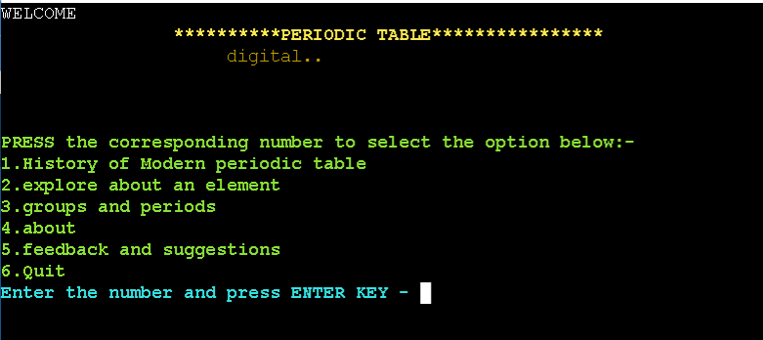

**>> We may select any option form the above list.**

**>> If we select 1 and press ENTER, then the history of periodic table will be printed as follows.**

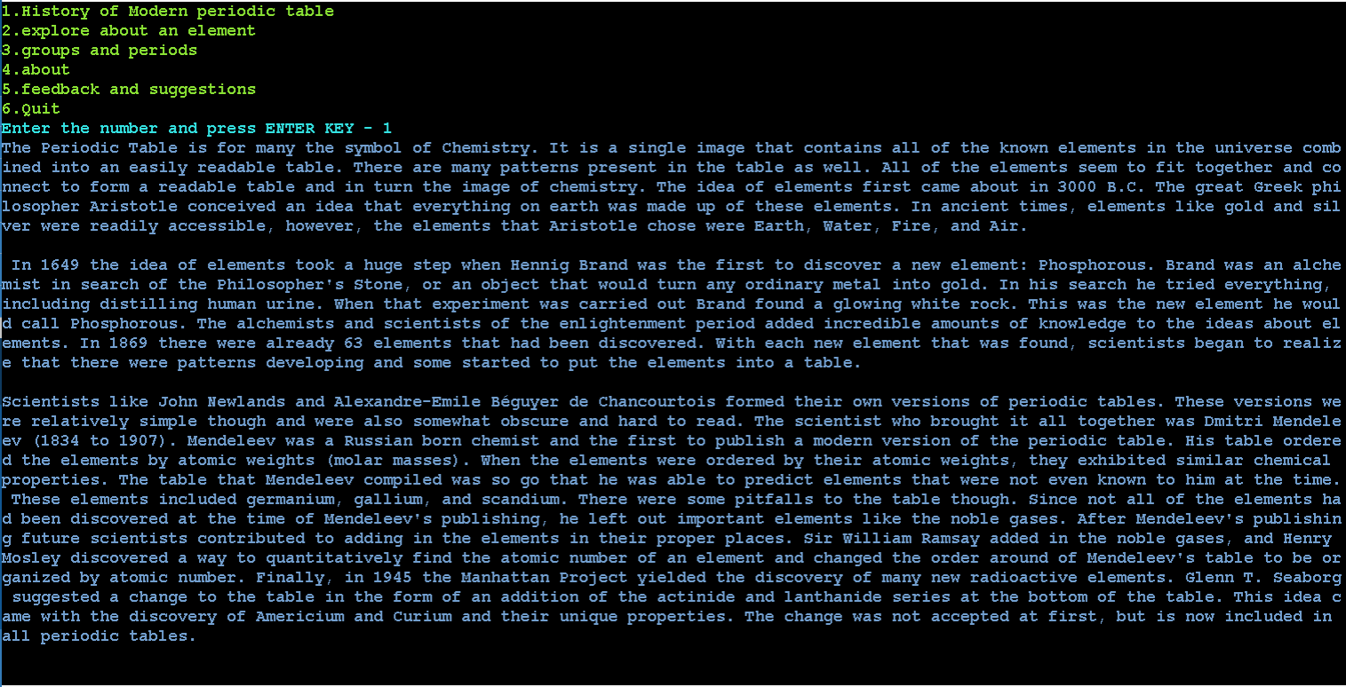

**>> If we select 2 ‘Explore an element’ , the following list of options will be displayed.**

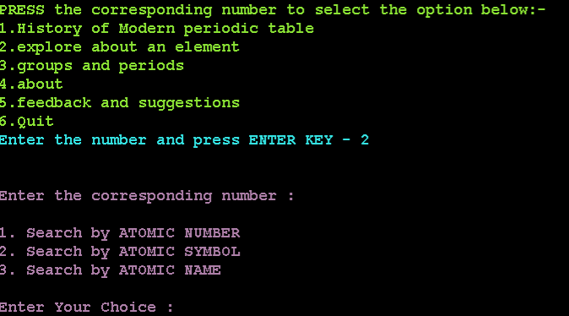

**>>Elements in periodic table can be explored any of the three ways as follows:**

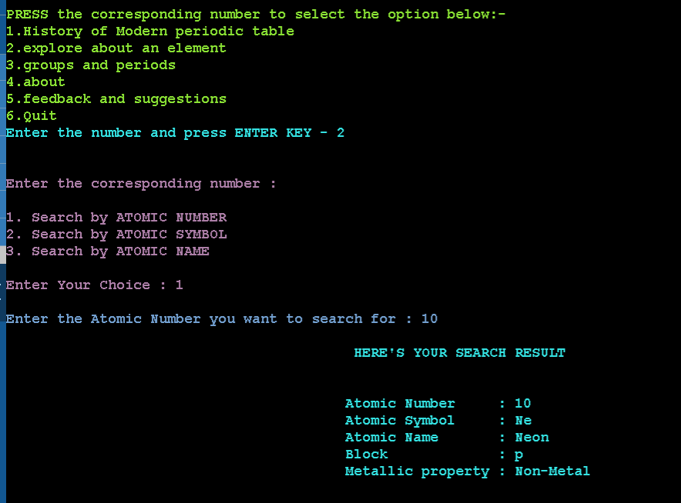

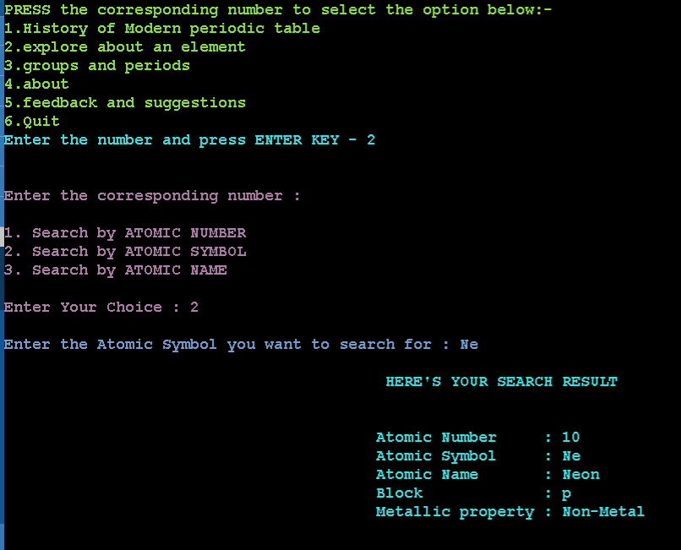

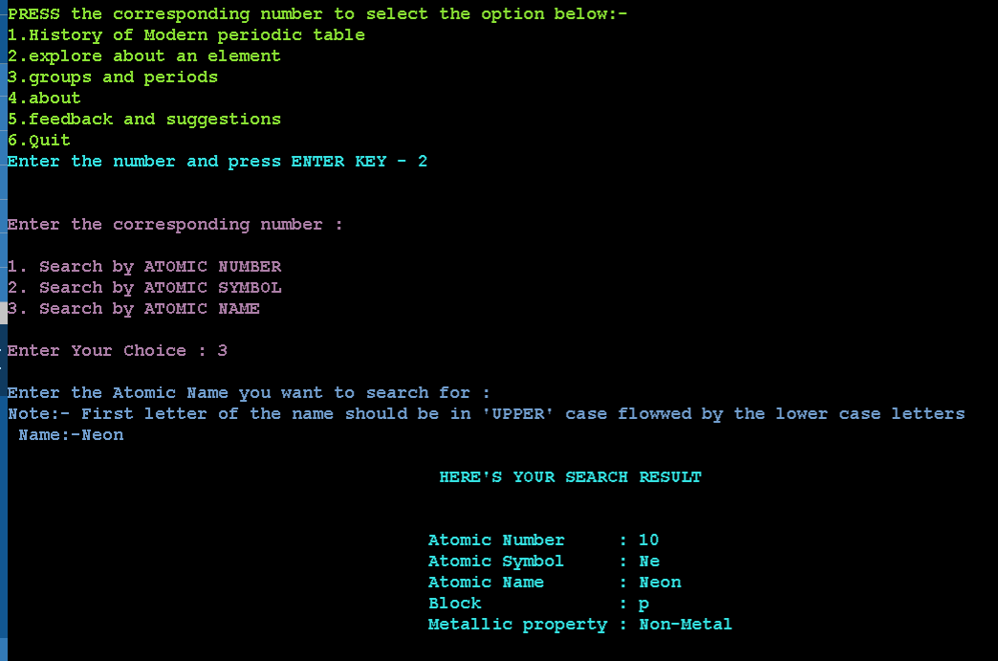

**>>If you select 3- ‘ Groups and periods’ , The following options are displayed:**

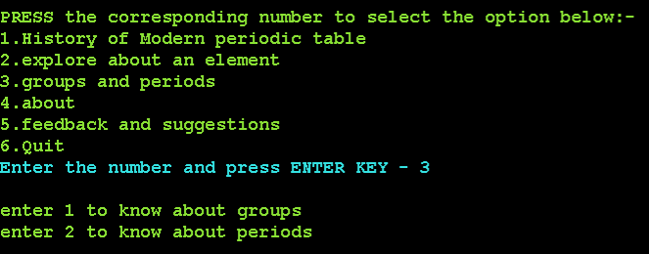

**>> Groups or periods can be explored by pressing corresponding options:**

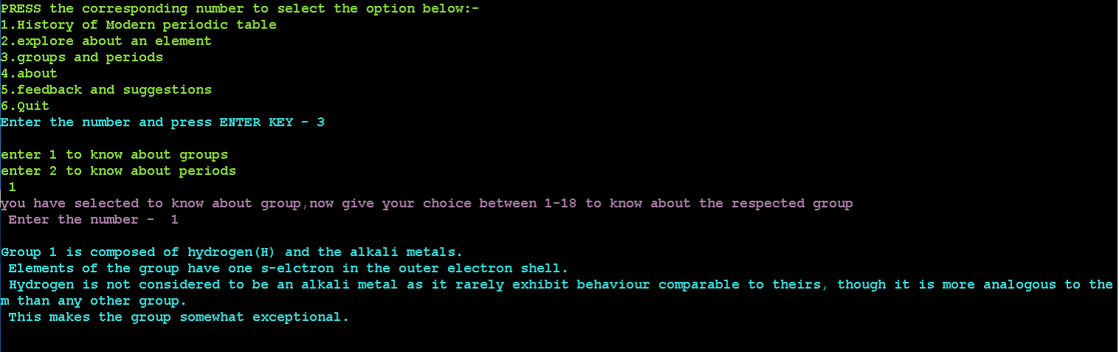

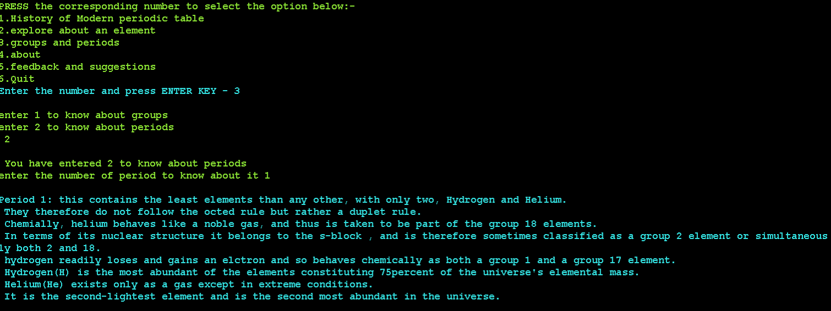

**>> Select 4 if you want to know about this ‘Modern-Periodic-Table_Digital’ C project.**

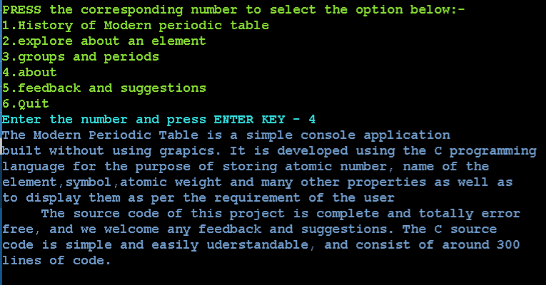

**>> Select 5 to give feedback:**

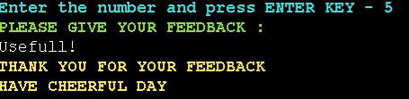

**>>Select 6 to Quit**

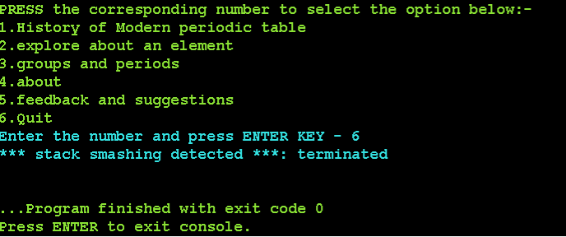

**Conclusion:**

**The Modern_Periodic_Table_Digital C code was executed successfully with zero errors.**

**The source Code of this project is attached with the GitHub Repository.**

**GitHub Repo link -** [**https://github.com/Charan-Nandarapu/Modern-Periodic-Table-Digital**](https://github.com/Charan-Nandarapu/Modern-Periodic-Table-Digital)

**For any queries or feedback, contact –** [**nandarapucharan065@gmail.com**](mailto:nandarapucharan065@gmail.com)

**THANK YOU!**